AetherAI- AI Powered Wearable System for Real-time Monitoring and Prediction of Respiratory Attacks

Pazhanivelrajan S
Department Of Artificial Intelligence and Machine Learning Sri Sai Ram Institute Of Technology Chennai, India sit24am047@sairamtap.edu
Dev Guru Akhil Sekar
Department Of Artificial Intelligence and Machine Learning Sri Sai Ram Institute Of Technology Chennai, India sit24am038@sairamtap.edu.in
Dr.Shanmugasundar.G Department Of Mechanical Engineering
Sri Sairam engineering college
Chennai, India

shanmugasundar.mech@sairamit.edu.in

Abstract—Respiratory conditions such as asthma, chronic bronchitis, and chronic obstructive pulmonary disease (COPD) represent a significant global health concern due to their sudden and unpredictable nature. Every year, a large number of individuals suffer from unexpected breathing difficulties that result in emergency medical care, prolonged health issues, emotional stress, and increased risk of serious outcomes. Most current healthcare approaches respond only after symptoms become severe, lacking systems for continuous observation and early risk detection that could help prevent critical situations.
This paper introduces Aether AI, an intelligent wearable solution designed to support early identification of respiratory distress through continuous monitoring. The system combines wearable sensor technology, IoT-based data transmission, and machine learning techniques to track key physiological and environmental indicators such as blood oxygen levels, breathing patterns, heart rate changes, temperature, humidity, and air quality. Collected data is analyzed using advanced predictive models, while a mobile application presents real-time health insights, alerts, and personalized respiratory information to users.
It providing early warnings before symptoms intensify, Aether AI promotes proactive health management and timely preventive measures, including medication use, rest, or changes in surroundings. This preventive approach helps reduce emergency events, hospital admissions, healthcare expenses, and patient anxiety. The project highlights the potential of integrating artificial intelligence, wearable devices, and cloud-based analytics to modernize respiratory healthcare and improve long-term disease management.
Keywords— Artificial Intelligence, Wearable Healthcare, Asthma Monitoring, Respiratory Attack Prediction, IoT, Smart Sensors, Health Analytics, Preventive Healthcare, Mobile Health.

INTRODUCTION
Respiratory illnesses, including asthma and chronic obstructive pulmonary disease (COPD), continue to pose major challenges to public health worldwide. Millions of people experience sudden respiratory complications every year, many of which require immediate medical intervention. Environmental pollution, changing climatic conditions, occupational exposure, and unhealthy lifestyles further increase the frequency and severity of these conditions.
Since respiratory attacks often develop rapidly without
obvious warning signs, patients remain at significant risk of emergency hospitalization and long-term health complications.

Recent advancements in wearable sensing technology, Internet of Things (IoT) communication, and artificial intelligence have created new possibilities for continuous health monitoring and predictive healthcare. By integrating physiological measurements with environmental information, intelligent wearable systems can recognize subtle changes that may indicate an increased risk of respiratory deterioration before clinical symptoms become apparent.

This research paper AetherAI, an AI-powered wearable healthcare system designed to continuously monitor respiratory health and predict potential respiratory attacks in real time. The proposed system combines physiological sensors for monitoring oxygen saturation, heart rate, respiration rate, and body temperature with environmental sensors that measure air quality, humidity, temperature, and harmful gases. Sensor data are transmitted securely to a cloud platform where machine learning algorithms analyze temporal patterns and estimate the likelihood of respiratory distress. The resulting predictions are delivered through a mobile application that provides real-time health visualization, personalized alerts, and timely preventive recommendations. By enabling early risk identification and proactive healthcare management, AetherAI aims to reduce emergency medical events, improve patient safety, and support sustainable healthcare practices aligned with the objectives of preventive medicine

PROBLEM STATEMENT
Despite ongoing innovation in digital healthcare, respiratory disease management continues to face several unresolved challenges:

  - Sudden asthma attacks occur without reliable early indicators.
    - Existing devices focus on post-symptom management rather than prevention.
    - Continuous real-time respiratory monitoring solutions remain limited and expensive.

• Environmental triggers such as air
pollution, humidity, and gas exposure are rarely

integrated into health tracking.
      - High dependence on emergency services increases healthcare burden and patient risk.
      - Lack of intelligent predictive models prevents early clinical intervention.

These limitations highlight the need for an integrated, intelligent, and wearable solution capable of predicting respiratory distress and supporting proactive health management.

SOLUTION DESCRIPTION
AetherAI is designed as a comprehensive AI-powered wearable ecosystem for respiratory health. The wearable device integrates multiple physiological and environmental sensors to continuously monitor the user’s respiratory condition and surrounding environment. Physiological parameters include oxygen saturation (SpO₂), heart rate, respiration rate, and body temperature. Environmental parameters include air quality index, gas concentration, humidity, and ambient temperature. These combined datasets allow the system to capture both internal and external triggers associated with asthma attacks.
The wearable device transmits collected data to a mobile application and cloud server via secure IoT communication protocols. The mobile application serves as an interactive interface, displaying real-time readings, historical trends, and personalized health insights. The cloud-based analytics engine hosts machine learning models that process incoming data streams, identify abnormal trends, and generate predictive risk scores.
The system architecture consists of:
  - Smart wearable sensing unit
  - Mobile monitoring and alert application
  - Cloud-based AI analytics and data management module.

Fig. 1. Overall System Architecture of AetherAI

INTERGRATED TECHINICAL AND NON-TECHNICAL FEEDBACK

Conventional respiratory monitoring systems rely primarily on physiological signals such as peak flow or oxygen saturation. However, asthma attacks are often triggered by environmental conditions including air pollution, temperature changes, allergens, and gas exposure. AetherAI addresses this limitation by integrating both physiological and environmental monitoring into a unified prediction framework. The system continuously correlates changes in breathing patterns and oxygen levels with variations in air quality, humidity, and temperature. This contextual awareness significantly enhances prediction accuracy. Early prototype testing demonstrated that abnormal environmental patterns often preceded physiological distress, validating the importance of dual-input monitoring. This integrated approach enables the AI model to learn complex interactions between internal health signals and external triggers, leading to more reliable early detection of respiratory risk.

METHODOLOGY

  - Data Collection:
The system collects physiological and environmental data using a dual-node wearable architecture. The ADS1292R captures ECG and respiration signals, while MAX30102 measures SpO₂ and heart rate. BNO055 detects motion and fall events, and BME688 monitors environmental conditions such as temperature, humidity, and air quality.

  - Data Preprocessing:
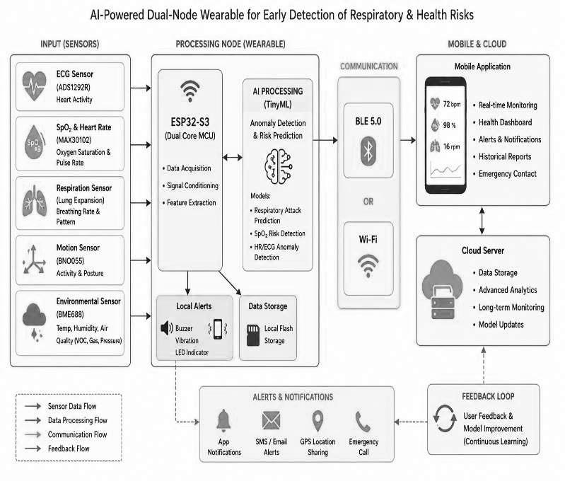
The acquired raw signals are processed using filtering and normalization techniques to improve accuracy. Important features such as heart rate variability, respiration rate, oxygen saturation trends, motion intensity, and environmental indices are extracted for further analysis.

  - Machine Learning-Based Prediction:
A TinyML-based model deployed on the ESP32-S3 analyzes the extracted features in real time. The system classifies the user’s condition into categories such as normal, mild risk, severe respiratory risk, and fall detection.

  - Alert Generation and Response System:
When abnormal conditions are detected, the system generates alerts through a buzzer and vibration motor. Notifications along with GPS location are sent to a mobile application for immediate response.
  - System Testing and Results:
The system is tested under various conditions to evaluate its performance. Results show reliable monitoring, accurate prediction, and timely alert generation, demonstrating its effectiveness for real-time healthcare applications.

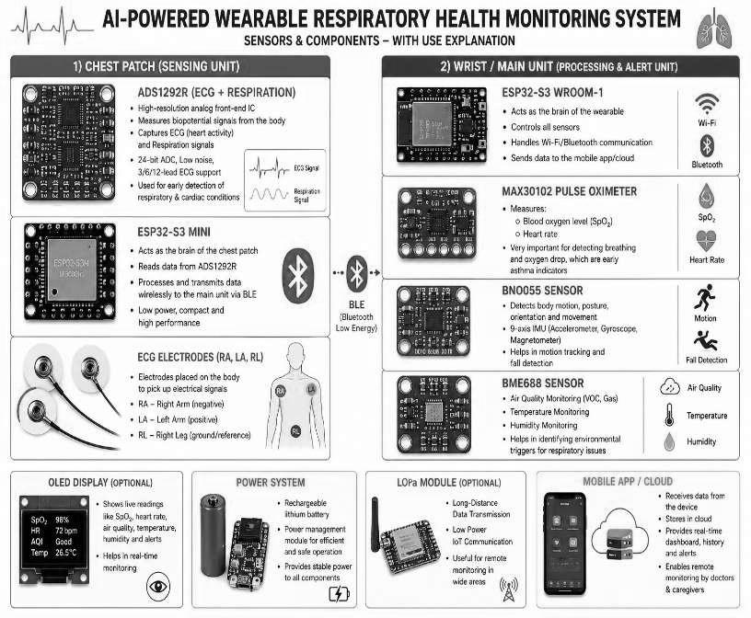
Fig.2. Hardware And Software Design

HARDWARE AND SOFTWARE DESIGN
The proposed wearable health monitoring system is built around the ESP32-S3 microcontroller, which functions as the central processing unit responsible for coordinating all sensing, processing, and communication tasks. The controller interfaces with the sensors integrated into both the chest and wrist wearable modules, enabling synchronized acquisition of physiological and environmental data. Its embedded Bluetooth Low Energy (BLE) capability facilitates energy-efficient wireless communication between the wearable device, mobile application, and cloud platform. Furthermore, the ESP32-S3 executes an embedded TinyML model to perform real-time health status prediction and anomaly detection directly on the device, thereby minimizing latency and reducing dependence on cloud-based processing.
To monitor cardiovascular and respiratory conditions, the wearable system incorporates the ADS1292R analog front-end, which provides high-resolution acquisition of electrocardiogram (ECG) and respiratory impedance signals. The sensor utilizes standard Right Arm (RA), Left Arm (LA), and Right Leg (RL) electrode configurations to ensure reliable bio-signal measurement. Its medical-grade signal acquisition capability enables accurate monitoring of cardiac electrical activity and respiration patterns, making it suitable for identifying abnormalities associated with cardiovascular and pulmonary disorders.
Blood oxygen saturation and heart rate are continuously monitored using the MAX30102 pulse oximeter sensor. This optical sensor measures peripheral oxygen saturation (SpO₂) and pulse rate through photoplethysmography (PPG). Continuous monitoring of these parameters supports the early detection of hypoxemia and other respiratory complications, thereby improving the effectiveness of real-time health surveillance.Human motion and body orientation are monitored using the BNO055 intelligent inertial measurement sensor. By integrating accelerometer, gyroscope, and magnetometer data with onboard sensor fusion algorithms, the device accurately detects posture, orientation, and movement patterns. This capability also enables reliable fall detection and prolonged inactivity monitoring, which are essential for identifying emergency situations, particularly among elderly individuals and patients requiring continuous supervision.
Environmental conditions surrounding the user are monitored using the BME688 environmental sensor. The sensor measures ambient temperature, relative humidity, atmospheric pressure, and volatile organic compounds (VOCs), providing a comprehensive assessment of air quality. Continuous environmental monitoring enables the system to identify potential respiratory triggers such as airborne pollutants, allergens, and harmful gases that may adversely affect individuals with chronic respiratory conditions.
The wearable device provides real-time visualization of health information through an optional OLED display or a connected mobile application dashboard. Physiological parameters including heart rate, blood oxygen saturation, respiration rate, and environmental air quality are presented in an intuitive format. Visual alerts and warning notifications are generated whenever abnormal physiological or environmental conditions are detected, enabling timely user awareness and intervention.
Wireless communication between the chest patch and wrist module is achieved using Bluetooth Low Energy (BLE) technology. BLE offers a reliable, low-power communication framework suitable for continuous wearable applications while maintaining extended battery life and seamless data transmission to mobile devices and cloud-based healthcare platforms.
The entire wearable system is powered by a rechargeable Lithium-Polymer (LiPo) battery, selected for its lightweight structure, high energy density, and suitability for portable healthcare devices. A TP4056 charging module with an integrated protection circuit is incorporated to ensure safe charging, prevent overcharging and deep discharge, and provide uninterrupted operation during continuous health monitoring. This power management architecture enhances the reliability, portability, and long-term usability of the proposed wearable healthcare system.

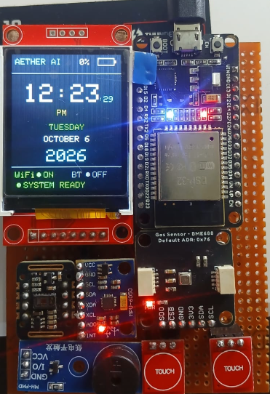

SOFTWARE DESIGN
The software side handles data processing, prediction, storage, and alerts.

Mobile Application
      - Displays live health data
      - Shows trends and reports
      - Sends alert notifications
      - Provides emergency guidance

Cloud Platform
  - Stores user health data
  - Runs AI models
  - Manages authentication and security

AI Analytics Engine
  - Applies machine learning models
  - Detects abnormal respiratory patterns
  - Predicts early attack risk
  - Continuously improves prediction accuracy

TECHNOLOGY STACK

The AetherAI system is built on a multi-layered technology stack that integrates embedded hardware, IoT communication, cloud computing, artificial intelligence, and mobile application development. This modular architecture ensures scalability, reliability, real-time performance, and secure health data processing.

Embedded Hardware and Firmware Layer

The wearable device is powered by the ESP32 microcontroller, selected for its low-power consumption, dual-core processing capability, and integrated Wi-Fi and Bluetooth modules. The ESP32 firmware is developed using the Arduino IDE / ESP-IDF framework, enabling real-time sensor interfacing, task scheduling, and wireless communication.

The firmware performs:

  - Multi-sensor data acquisition (I2C, ADC, GPIO interfaces)
  - Signal conditioning and noise filtering
  - Timestamp synchronization
  - Local threshold checkingSecure data packet formation

Communication protocols such as MQTT and HTTPS are implemented to ensure lightweight, real-time, and secure data transmission.

Power optimization is achieved using:
- Deep sleep modes
- Duty-cycling of sensors
- Battery voltage monitoring

This allows the wearable to operate efficiently for long-term continuous monitoring.

IoT Communication and Data Transmission Layer

The system uses MQTT (Message Queuing Telemetry Transport) for real-time streaming of sensor data to the cloud. MQTT is chosen due to its low overhead, publish–subscribe architecture, and reliability in low-bandwidth environments.

Additional communication services include:

  - RESTful APIs for data synchronization
  - TLS/SSL encryption for secure transmission

  - Device authentication tokens to prevent unauthorized access

This layer ensures real-time, fault-tolerant, and secure communication between the wearable, cloud server, and mobile application.

Cloud Infrastructure and Backend Services

The backend system is deployed on AWS / Google Cloud Platform, providing elastic scalability, fault tolerance, and high availability.

Key cloud services include:

  - Firebase / AWS DynamoDB for real-time database storage

  - Cloud Functions / Lambda services for event-based processing

  - Authentication services for secure user identity management
  - Data pipelines for long-term health record storage

All incoming sensor data is stored in structured and time-series databases, enabling trend analysis, historical visualization, and machine learning model training

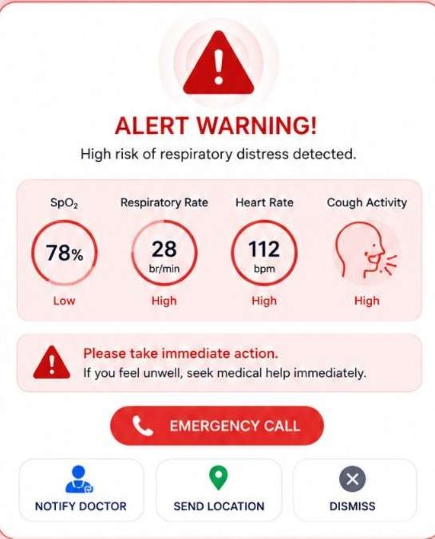
Fig.3. System Output Window

d.Artificial Intelligence and Machine Learning Layer
The models classify respiratory states into:

- Normal
- Warning
- High-risk

Risk scores are generated using probability-based inference models. Continuous learning mechanisms allow the system to adapt to personalized baseline patterns for each user.
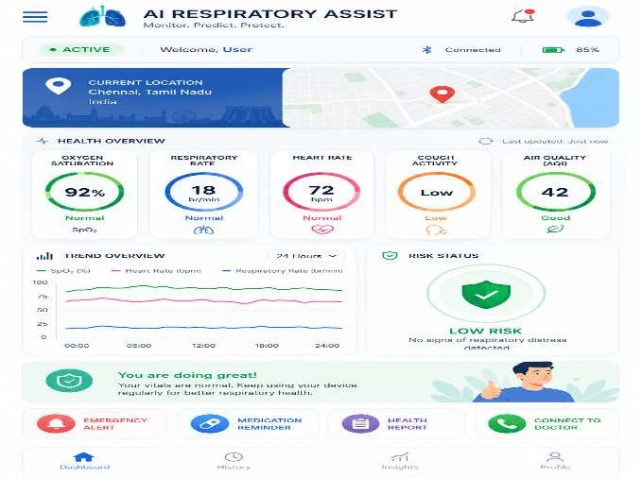
Dashboard

Mobile Application and Visualization Layer

The mobile application is developed using Flutter / React Native, ensuring cross-platform compatibility for Android and iOS.

The app provides:
  - Live sensor dashboards
  - Time-series health graphs
  - Environmental condition visualization
  - AI-generated alerts and notifications
  - Emergency response guidance Additional features include:
  - Bluetooth/Wi-Fi pairing modules
  - Background service monitoring
  - Secure login and encrypted local storage
  - Push notifications are implemented using Firebase Cloud Messaging (FCM) to ensure instant alert delivery.

Data Analytics, Security, and System Integration
For data analytics and visualization:

  - Pandas and Matplotlib are used for offline model training

  - OpenCV supports signal enhancement and sensor validation
  - Grafana dashboards can be integrated for clinician-level analytics
Security mechanisms include:
  - End-to-end encryption
  - Secure API gateways
  - Role-based data access

  - Compliance with healthcare data protection principles

System Architecture Summary

The technology stack ensures:
  - Low-power embedded operation
  - High-frequency real-time data acquisition

  - Cloud-based AI-driven analytics
  - Secure, scalable health data management
  - User-friendly mobile health interaction

This integrated stack enables AetherAI to function as a reliable cyber-physical healthcare system capable of continuous respiratory monitoring and early attack prediction.

Ethical, Privacy, and Security Considerations.

AetherAI is designed with strong ethical, privacy, and security principles, as it handles highly sensitive physiological and health-related data. The system follows a privacy-by-design approach, ensuring that only essential health parameters are collected and that users provide informed consent before any data storage or processing. All personal and medical information is encrypted at the device, transmission, and cloud levels using secure authentication, SSL/TLS communication, and protected databases to prevent unauthorized access, data breaches, or misuse.
Ethically, AetherAI functions strictly as a decision-support system rather than a diagnostic replacement, ensuring that medical authority remains with healthcare professionals. The artificial intelligence models are developed to be transparent, explainable, and conservative in prediction to avoid unnecessary panic and psychological stress.

Bias reduction strategies, including diverse training datasets and continuous performance validation, are incorporated to ensure fairness and inclusivity across different user populations. Furthermore, users maintain full control over their data, including access permissions and deletion rights. By integrating responsible AI practices, secure system architecture, and patient-centric design, AetherAI ensures trust, safety, accountability, and compliance with modern healthcare data protection standards.

XI. CONCLUSION
This study presented AetherAI, an intelligent wearable healthcare system developed to facilitate the early detection and prediction of respiratory attacks through continuous physiological and environmental monitoring. By integrating wearable sensors, IoT-based communication, cloud computing, and machine learning techniques, the proposed framework addresses the limitations of conventional respiratory care, which largely depends on reactive treatment after symptom onset.

The developed system continuously measures critical health indicators, including blood oxygen saturation, heart rate, respiration rate, body temperature, and surrounding environmental conditions. Machine learning algorithms analyze these multidimensional data streams to recognize abnormal patterns associated with respiratory deterioration and generate early warning notifications through a mobile application. This predictive capability enables users to take preventive actions before severe respiratory complications develop, thereby improving patient safety and reducing dependence on emergency medical services.

Future work will focus on validating the proposed system using larger clinical datasets, enhancing prediction accuracy through advanced deep learning models, and incorporating personalized adaptive learning techniques.
Integration with electronic health record systems and healthcare providers will further strengthen its clinical applicability. Overall, AetherAI demonstrates how the convergence of artificial intelligence, wearable sensing, and IoT technologies can transform respiratory healthcare from reactive treatment toward predictive, preventive, and personalized medical care.

XI. OUTPUT
The implementation and testing of the AetherAI system resulted in several significant technical and functional outcomes that demonstrate its effectiveness as a predictive respiratory healthcare solution.
The system successfully achieved continuous real-time monitoring of vital respiratory parameters including oxygen saturation, heart rate, breathing trends, temperature, humidity, and surrounding air quality. This enabled uninterrupted health tracking without user intervention, ensuring reliable long-term observation.
.
The mobile application provided instant alerts and visual health insights, allowing users to understand their respiratory condition, track historical trends, and respond proactively. This resulted in improved user awareness, reduced anxiety, and greater confidence in managing respiratory health.

Additionally, AetherAI established a scalable framework for future clinical integration, remote health monitoring, and AI-driven respiratory analytics, making it suitable for both individual users and broader public health applications.
Overall, the project output validates that AetherAI is a feasible, intelligent, and impactful solution capable of transforming respiratory disease management through predictive healthcare technology.

XII. REFERENCE
[1] M. Chan et al., “Smart wearable systems: Current status and future challenges,” Artificial Intelligence in Medicine, vol. 56, pp. 137–156, 2012.
[2] Y. Zheng, X. Ding, C. Poon et al., “Unobtrusive sensing and wearable devices for health informatics,” IEEE Transactions on Biomedical Engineering, vol. 61, no. 5, 2014.
[3] T. Hughes et al., “Machine learning for respiratory disease prediction using wearable sensors,” IEEE Journal of Biomedical and Health Informatics, 2021.
[4] A. Clifton et al., “Predictive monitoring of respiratory health using wearable biosensors,” Sensors, MDPI, 2022.
[5] Espressif Systems, “ESP32 Technical Reference Manual,” 2023.
[6] Analog Devices, “MAX30102 High-Sensitivity Pulse Oximeter Datasheet,” 2022.
[7] Winsen Sensor Technology, “MQ Series Gas Sensor Technical Documentation,” 2021.
[8] S. R. Steinhubl, E. D. Muse, and E. J. Topol, “The emerging field of mobile health,” Science Translational Medicine, 2015.
[9] U.S. National Library of Medicine, “Wearable devices for asthma monitoring,” MedlinePlus, 2022.
[10] G. Yang et al., “IoT-enabled wearable sensor systems for healthcare,” IEEE Internet of Things Journal, vol. 5, no. 4, 2018.
[11] D. Ravi et al., “Deep learning for health informatics,” IEEE Journal of Biomedical and Health Informatics, vol. 21, no. 1, 2017.
[12] H. Banaee, M. U. Ahmed, and A. Loutfi, “Data mining for wearable sensors in healthcare,” Sensors, vol. 13, no. 12, 2013.
[13] J. Wang et al., “Wearable sensing and machine learning for respiratory monitoring,” IEEE Reviews in Biomedical Engineering, 2020.
[14] R. Miotto et al., “Deep learning for healthcare: review, opportunities and challenges,” Briefings in Bioinformatics, 2018.
[15] A. Holzinger et al., “Explainable AI in healthcare,” Wiley Interdisciplinary Reviews: Data Mining and Knowledge Discovery, 2019.

